Audio Books from Audible | iBooks | Pages
Catholic Study Bible App | iBreviary Pro Terra Sancta HD | 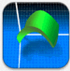  Quick Graph: Your Scientific Graphing Calculator
Follett Enlight K-12 Edition | iMovie | Quizlet
Evernote | Keynote | 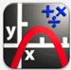  Free Graphing Calculator (William Jockusch)
Find My iPhone | Kindle | Sketch-pad
Google Drive | 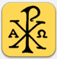  Laudate (prayers) | The Pope App
Google Maps | Notability | Turnitin

